Vogogo Grocery Cart Readme.  
  
  
This will provide the end user a quick guide on how to use the Vogogo Grocery cart program.   
  
As the solution is javascript based (HTML markup in browser) the user can simply right click on the file VoGoGo.html and select to “Open with Chrome”, or “Open with Mozilla FireFox” as these are the two browser the solution has been tested on.  
  
Once the solution has loaded in the users browser it will look like such.

* 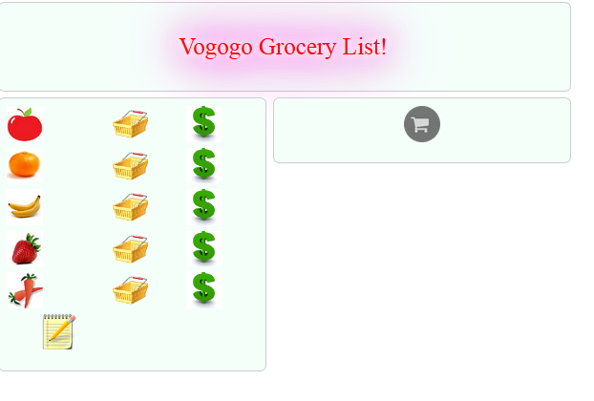Clicking the shopping basket button will allow the user to add as many of the specified item as desired (2 digits).
* Clicking the dollar sign will allow the user to set up specific pricing rules of the specified item as desired.
* Clicking on the shopping cart button on the right side of the page will compile a list of all selected items, implementing their pricing rules (if applied) in the price. The total checkout cost is also calculated.

Notes: - An unordered list of all items prints under the notepad item once the user has selected each item.

* Items can be purchased as many times as desired in quantities below 100 by reclicking the shopping basket associated with the desired item.
* Rules and item quantities are maintained until page reload.
* Like items, rules can be applied at any time.
* Rules for items of same quantity ex (5 apples for 2 dollars, and 5 apples for 1.50) are not handled and the first rule to be implemented will be applied first.
* Textboxes are not validated, (only validation is item # <100, per item input).
* Textboxes maintain previous values.

Quick demo video: <https://www.youtube.com/watch?v=7utZiOIAfXU>

* Had to implement an interface as I am without an IDE on my home machine other than visual studio 2012 .